**Asynchronous Activity 3- Cause & Effect Analysis.**

**Objective:** Perform *Cause-Effect Analysis* to be able to thoroughly understand a system’s problems, opportunities, and/or directives that triggered the project.

***LO1:*** *Demonstrate understanding of the concepts and basic principles of system development to meet client/community requirements.*

***LO2:*** *Produce a set of documents and models for a new system by applying fact finding, problem solving and object-oriented analysis modelling techniques and by using appropriate software tools.*

**Instructions**:

* Naming convention for the document is “**StudentID_FirstName”**.
* Submit your Work through the link provided on Moodle in same week.
* Your attendance will be considered based on your submission.
* Don’t plagiarise and do your own analysis.

1. Use MS Visio or any software that support Ishikawa (fish bone) diagram or use PowerPoint Template and Use **6 M’s model** to doCause-and-Effect’ analysis for **‘Dissatisfied Airline Customer’**. Make sure two add minimum 2 causes for each category. Take a screen shot of your diagram and paste it in following word document and submit with proper naming convention.

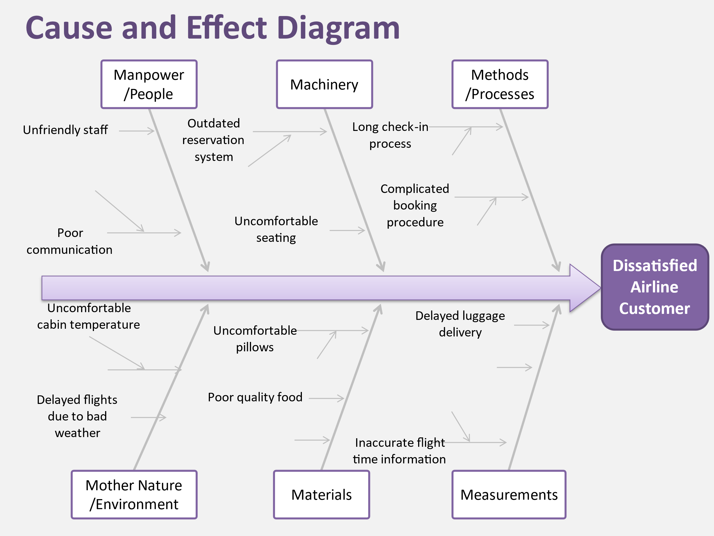

1. Use Ishikawa to do Cause-and-Effect’ analysis for ‘**Flight Delays**’. You can use any 4 categories from the 6 M’s model and add minimum 2 causes in each category.

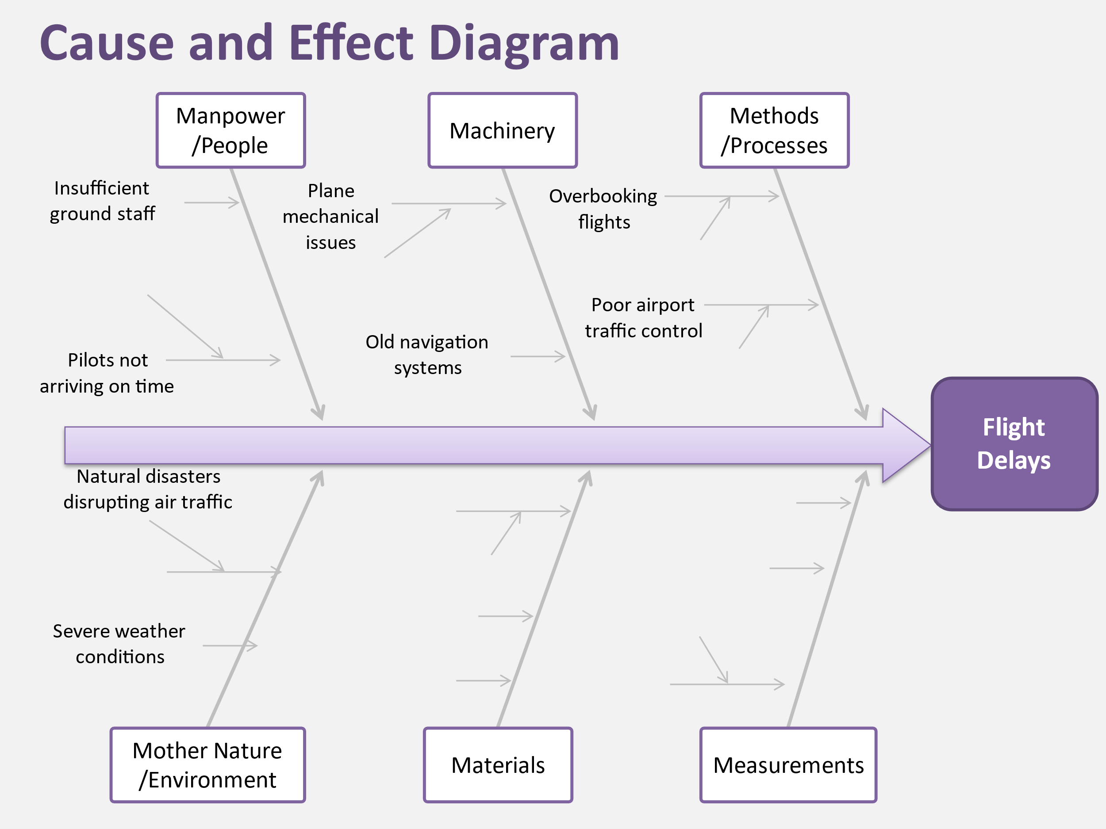

(Note: You can have more than 2 causes if you can think)